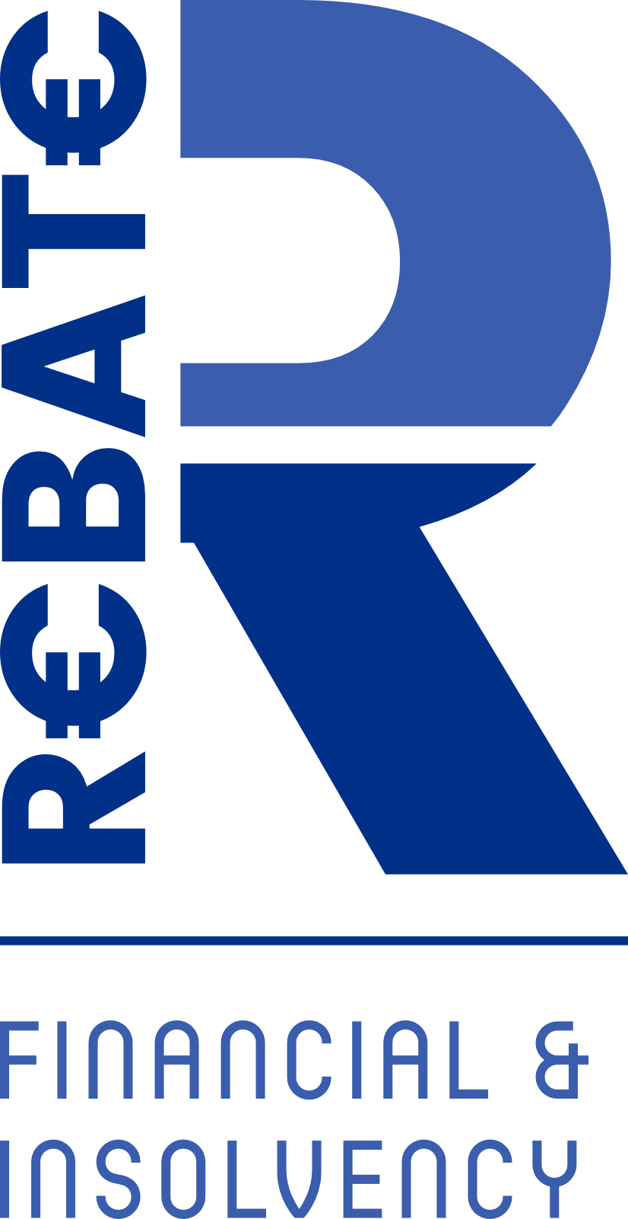

GDPR DOCUMENT

You may have heard about the GDPR, but you may not be entirely sure how it will affect your relationship with REBATE. So, here’s a quick run-through of what it all means for you as a REBATE customer. For full details, please read our Data Protection Notice.
What is the GDPR?
The EU is introducing a regulation – the General Data Protection Regulation (GDPR)
- to strengthen data protection for all within the European Union. GDPR is good news for customers. It makes it easier for you to access your personal information and control how it is used.
When is it coming?
May 25, 2018.
Why does REBATE collect and use my personal information in the first place?
There are a number of reasons why REBATE collects and uses your personal information. We have outlined just some of these reasons below but if you’d like to find out more, please read our Data Protection Notice.
- To process your applications
- To help administer your products and services
- To ensure we provide you with the best service possible
- To prevent unauthorised access to your accounts
- To meet our legal and regulatory obligations
Speaking of which, what is a Data Protection Notice?
A Data Protection Notice is a document that every organisation who processes personal information must produce and make available. It gives detailed, but simple, explanations of how REBATE manages your personal information.

What are some of the key changes I will see as a customer?
The GDPR will give you greater control over your personal information by setting out additional and more clearly defined privacy rights, which you can exercise.
Rights for customers under the GDPR include:
- The right to access personal information an organisation holds on you
- The right to have inaccuracies corrected
- The right to have information erased
- The right to object, including in relation to direct marketing
- To restrict processing
- The right to have your personal information sent directly to yourself or another organisation
- Rights in relation to automated decision making and profiling
You can find out about your privacy rights and how you can control the personal information REBATE holds.
Does REBATE share my personal information?
We sometimes need to share your personal information with trusted third parties who perform important functions for us. For example, we use third parties to help us address fraud, security or technical issues. REBATE is also required to cooperate by law or otherwise through a legal process with Irish, EU regulatory or enforcement bodies.
How secure and confidential is my personal information?
We use a variety of security technologies and procedures to help protect your personal information from unauthorised access, use or disclosure. The security of your personal information is exceptionally important to us and we put a huge effort into protecting it. Our Data Protection Notice outlines how we do this in more detail. For example we use Microsoft 365 for all e mail accounts, Word and excel documents.
For how long does REBATE retain my personal information?
This depends on the nature of the information we hold and the purposes for which it is processed. Sometimes there are statutory obligations (imposed on us by law). For example, we have to retain some customer information for 6 years after the end of the customer relationship under the Consumer Protection Code and the Personal Insolvency legislation.

